3. Program to implement Naïve Bayes algorithm using any standard dataset available in the public domain and find the accuracy of the algorithm.

import numpy as np

import matplotlib.pyplot as plt

import pandas as pd

dataset = pd.read_csv('Social_Network_Ads.csv')

x = dataset.iloc[:, [2, 3]].values

y = dataset.iloc[:, -1].values

from sklearn.model_selection import train_test_split

X_train, X_test, Y_train, Y_test = train_test_split(x,y, test_size=0.20, random_state=1)

from sklearn.preprocessing import StandardScaler

sc = StandardScaler()

X_train =sc.fit_transform(X_train)

X_test = sc.fit_transform(X_test)

print(X_train)

print(X_test)

from sklearn.naive_bayes import GaussianNB

classifier = GaussianNB()

classifier.fit(X_train, Y_train)

Y_pred = classifier.predict(X_test)

print(Y_pred)

from sklearn.metrics import confusion_matrix, accuracy_score

ac = accuracy_score(Y_test, Y_pred)

print(ac)

**Output 2**

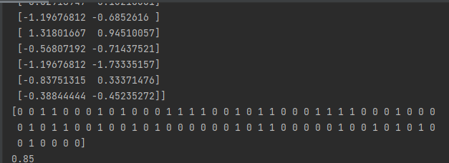

4. Program to implement linear and multiple regression techniques using any dataset available in the public domain and evaluate its performance.

Linear regression

import numpy as np

import matplotlib.pyplot as plt

from sklearn.linear_model import LinearRegression

x=np.array([23,43,41,73,71]).reshape((-1,1))

y=np.array([68,24,72,36,56])

print(x)

print(y)

model=LinearRegression()

model.fit(x,y)

r_sq=model.score(x,y)

print('coefficient of determination:',r_sq)

print('intercept:', model.intercept_)

print('slope: ',model.coef_)

y_pred = model.predict(x)

print('predicted response:', y_pred)

plt.scatter(x,y, color="m")

plt.plot(x,y_pred, color="g")

plt.xlabel('x')

plt.ylabel('y')

plt.show()

Linear regression (without using regression function)

import numpy as np

import matplotlib.pyplot as plt

def estimate_coef(x,y):

n=np.size(x)

m_x = np.mean(x)

m_y = np.mean(y)

ss_xy = np.sum(y * x) - n * m_y * m_x

ss_xx = np.sum(x * x) - n * m_x * m_x

b_1 = ss_xy / ss_xx

b_0 = m_y -b_1 * m_x

return (b_0,b_1)

def plot_regression_line(x,y,b):

plt.scatter(x , y , color="m")

y_pred = b[0]+b[1]*x

plt.plot(x , y_pred, color="g")

plt.xlabel('x')

plt.ylabel('y')

plt.show()

def main():

# observations / data

x = np.array([9,5,6,7,4,5])

y = np.array([3,2,1,5,7,10])

b = estimate_coef(x, y)

print("Estimated coefficients:\nb_0 = {} \

\nb_1 = {}".format(b[0], b[1]))

plot_regression_line(x, y, b)

if __name__ == "__main__":

main()

**output**

